Ping scan
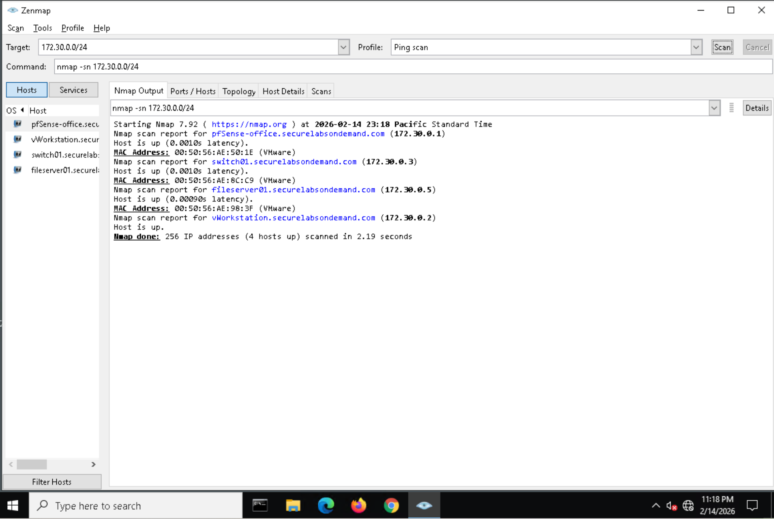

File server host
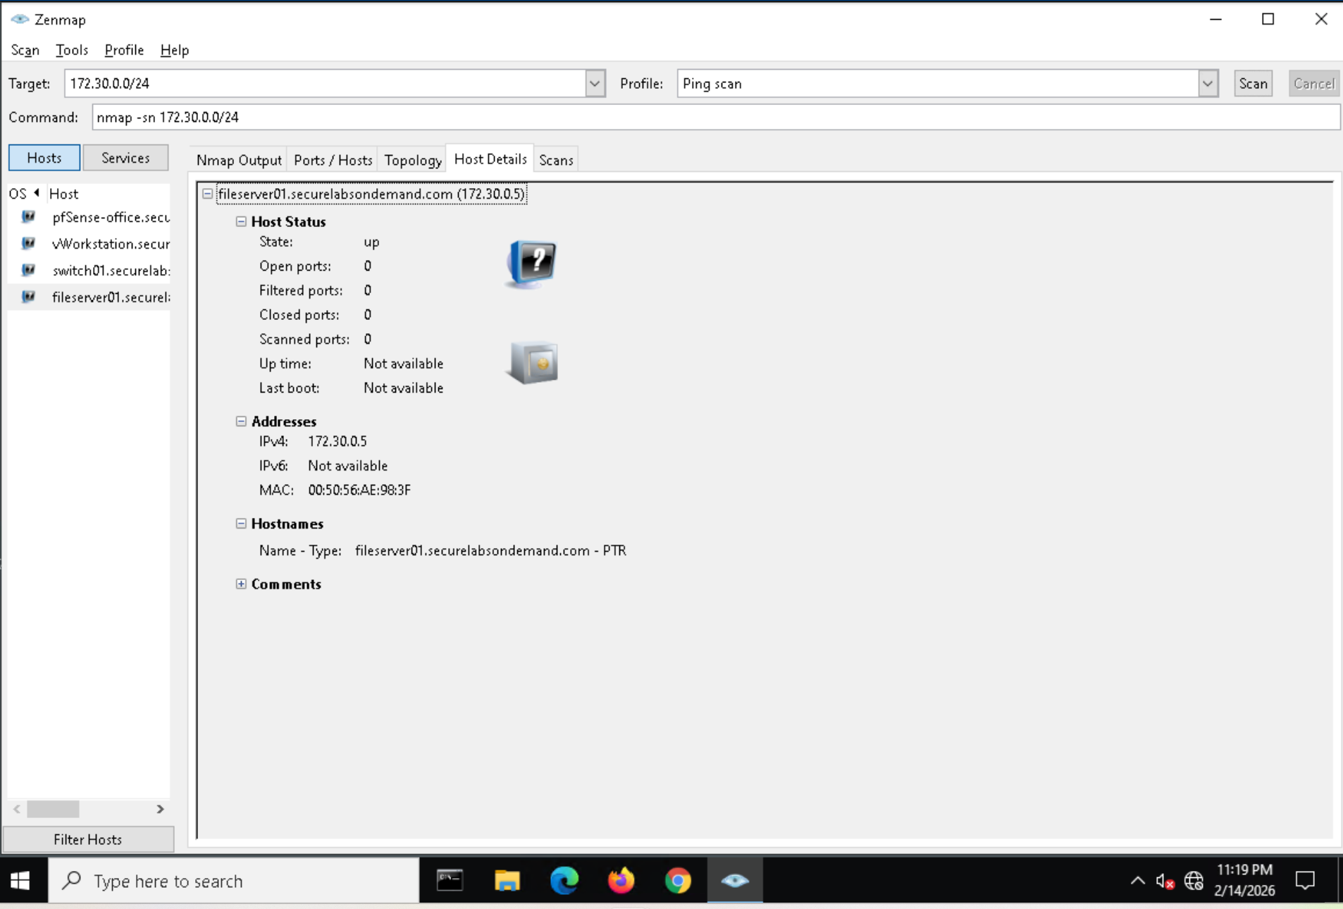

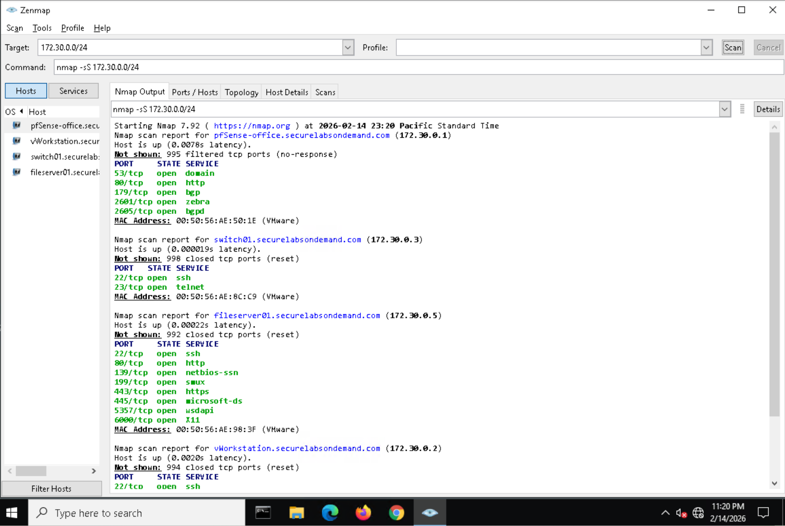syn scan result

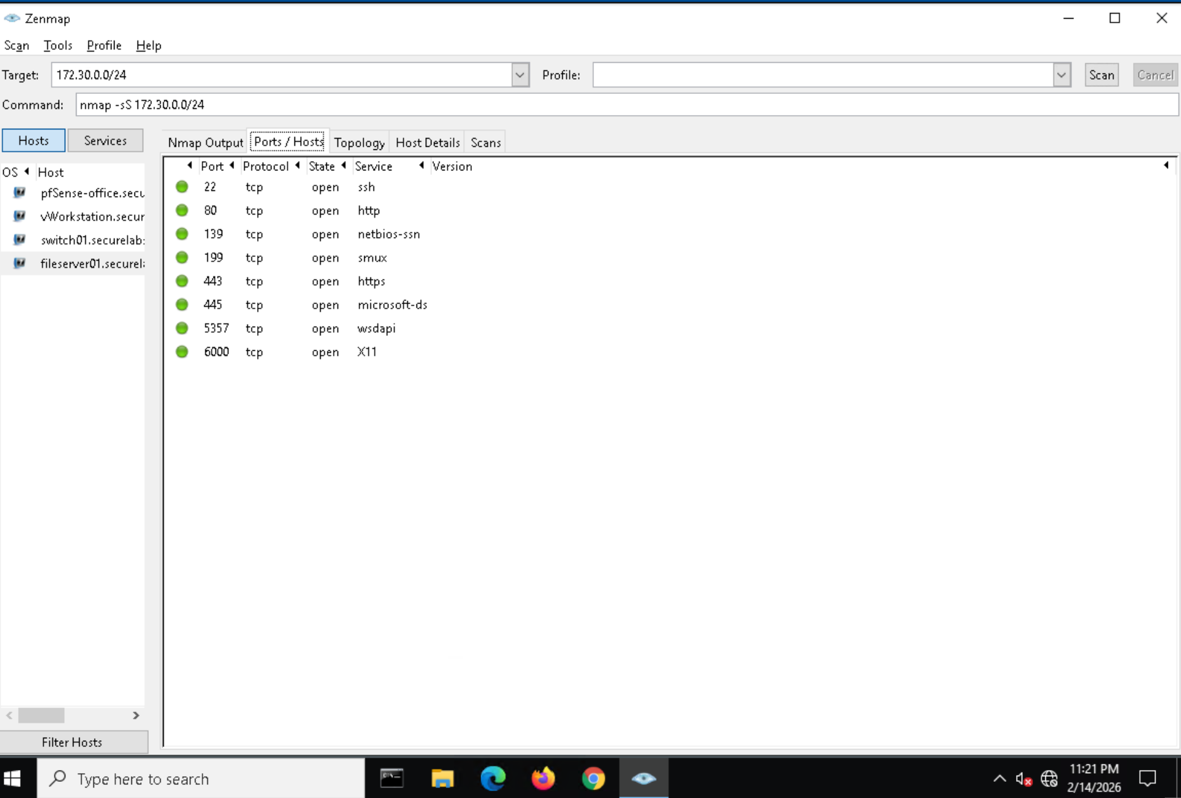
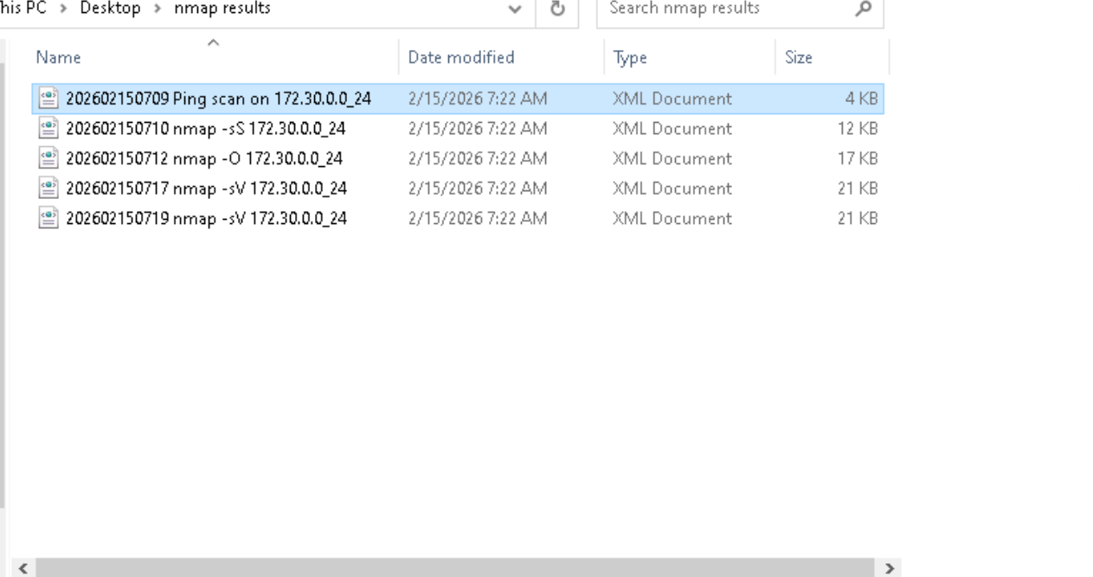
Results of scan

----------------------------------------SECTION 2-------------------------------------------------------------------------
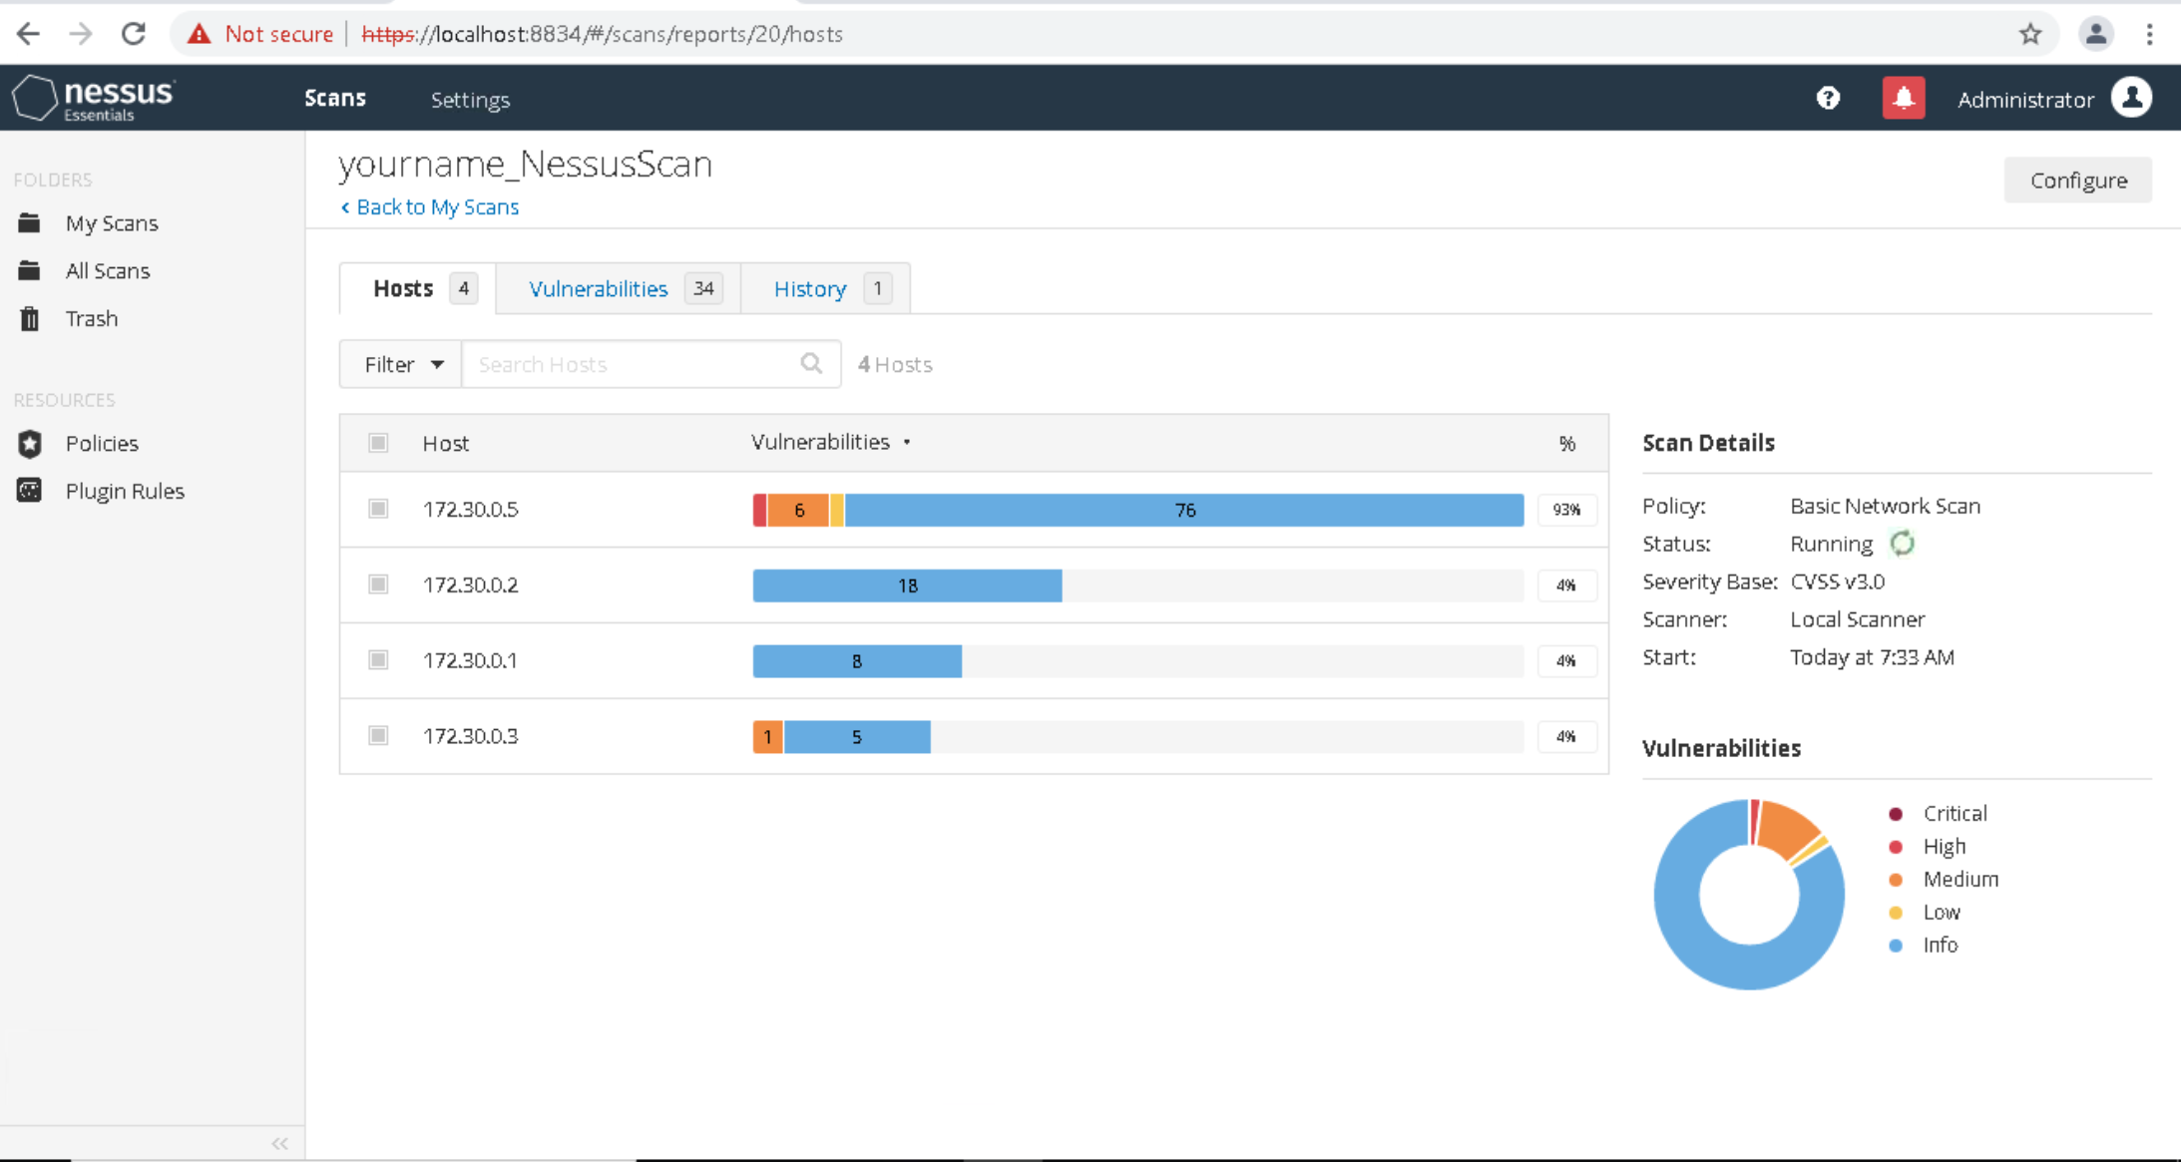
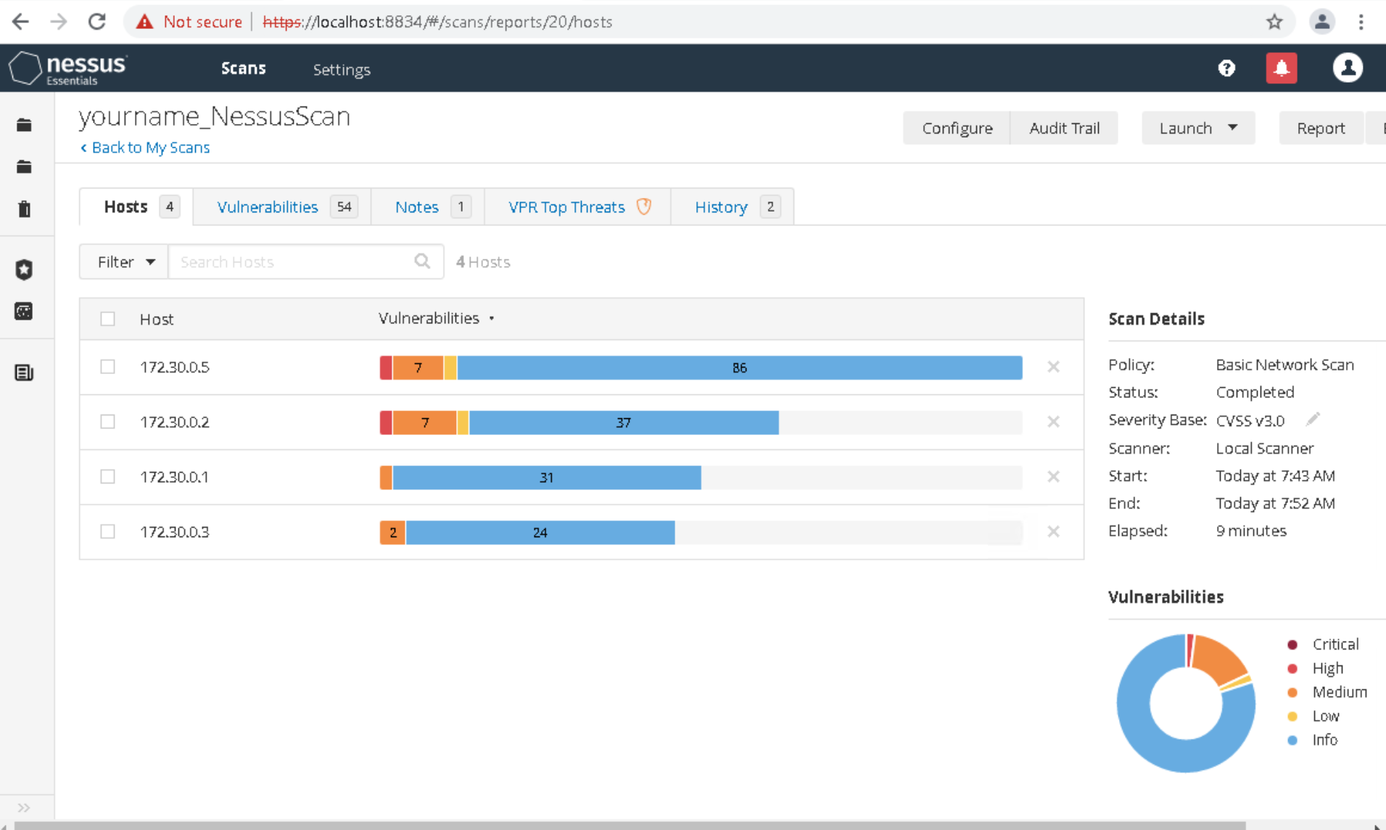
REPORT HAS BEEN FOUND FOR YOURNAME_NESSUSSCAN

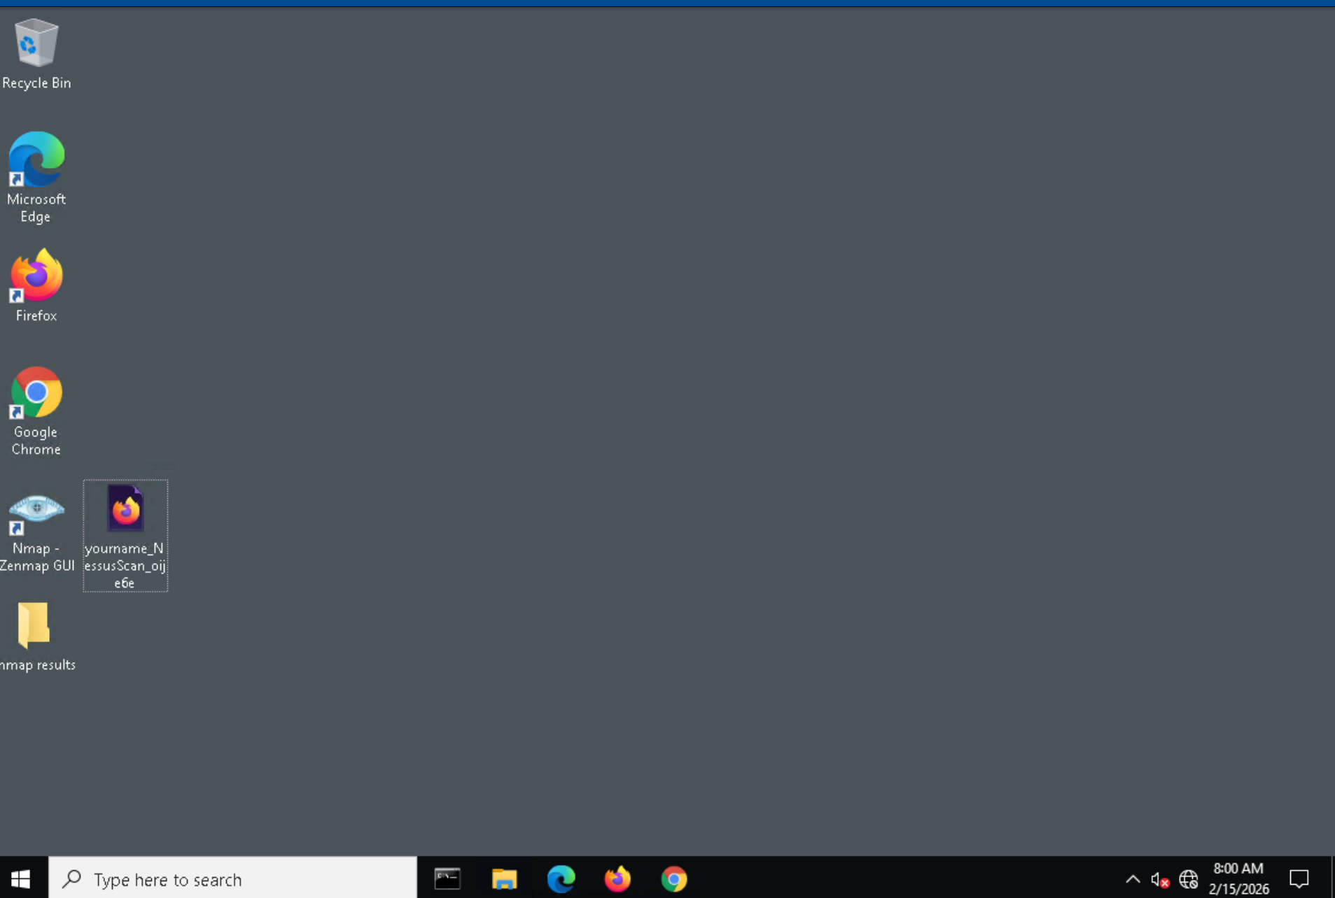
Report has been generated and pasted into the vworkstation’s desktop

----------------------------------------SECTION 3-------------------------------------------------------------------------
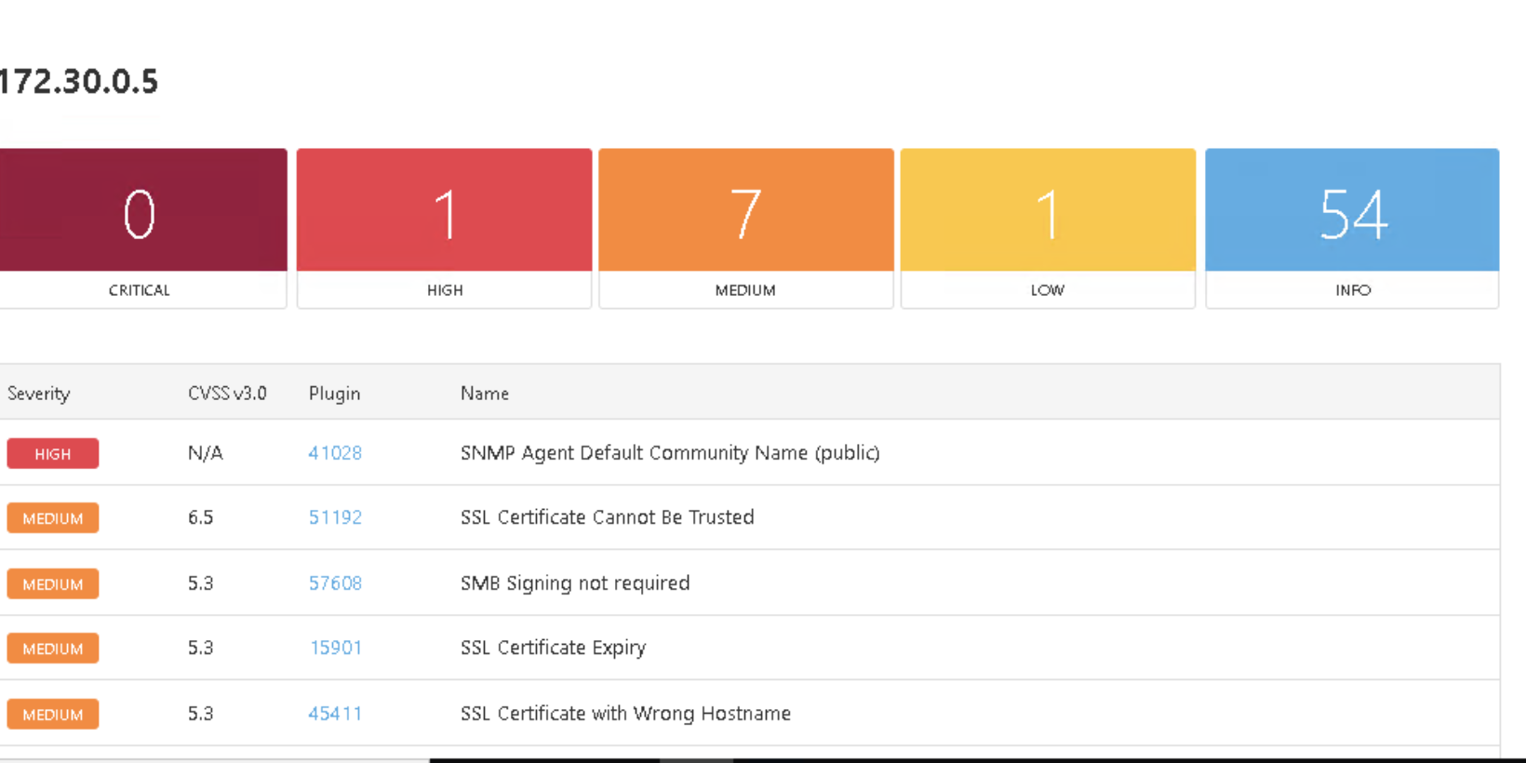
Report of ip 172.30.0.5

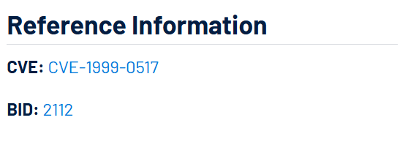
Cve value identified for for Nessus page 41028

The scan detected that the host 172.30.0.2 supports TLS 1.0, which is an outdated and deprecated cryptographic protocol. TLS 1.0 is vulnerable to several known attacks such as BEAST and other cryptographic weaknesses. Modern security standards (PCI DSS, NIST) no longer consider TLS 1.0 secure.
If TLS 1.0 remains enabled:

Attackers may exploit cryptographic weaknesses

Sensitive data may be exposed during transmission

The system may fail compliance audits (PCI, ISO, etc.)

Increased risk of man-in-the-middle (MITM) attacks

Although not immediately critical, it weakens overall transport security.

CVSS v3.0 Score: 6.5 (Medium Severity)
Recommended Mitigation Strategy

Disable TLS 1.0 and TLS 1.1 on the server.

Enable only secure protocols:

TLS 1.2

TLS 1.3 (preferred)

Update server configuration:

For Apache → modify ssl.conf

For Nginx → update ssl_protocols

For Windows Server → disable via registry or IIS Crypto

Restart the service after changes.

Re-scan the system to confirm remediation.

Conclusion

The system is currently supporting deprecated TLS 1.0 protocol, resulting in a CVSS score of 6.5 (Medium). Disabling legacy protocols and enforcing TLS 1.2/1.3 will significantly improve transport layer security and reduce exposure to cryptographic attacks.

<Section 1 of assignement 1 over>

Step 1
Executed ping command form the kali linux
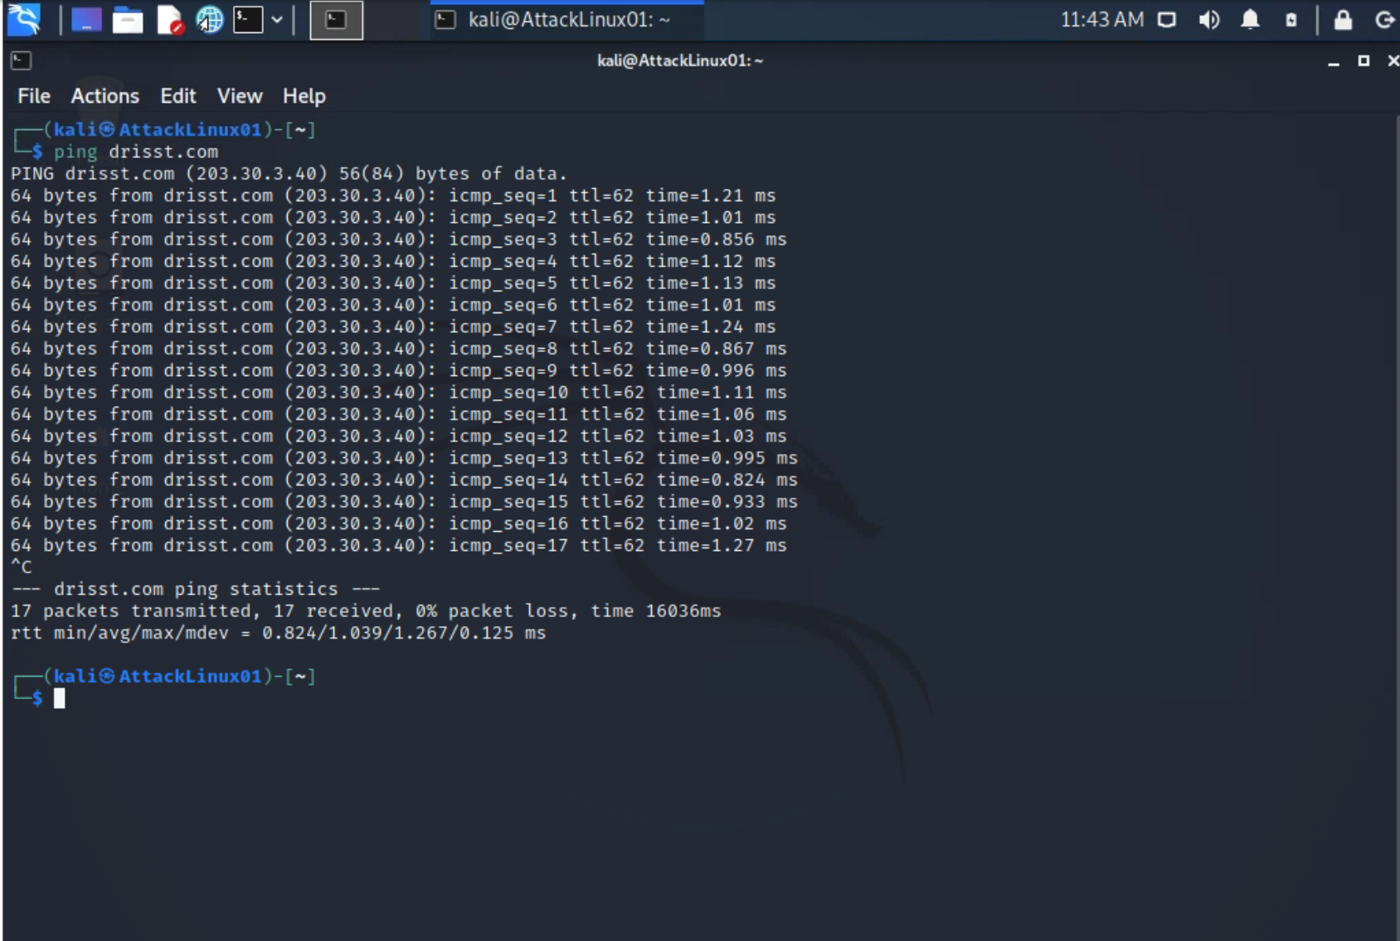

Executed traceroute
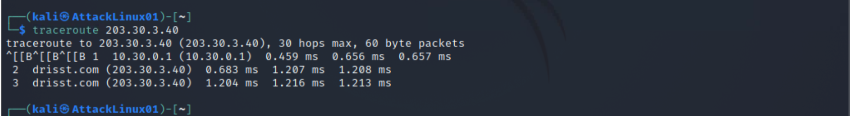

Execute nmap
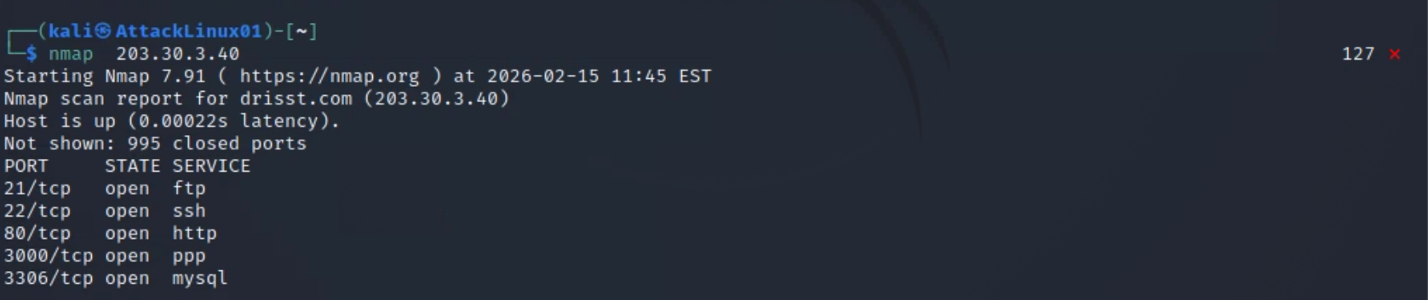
8.
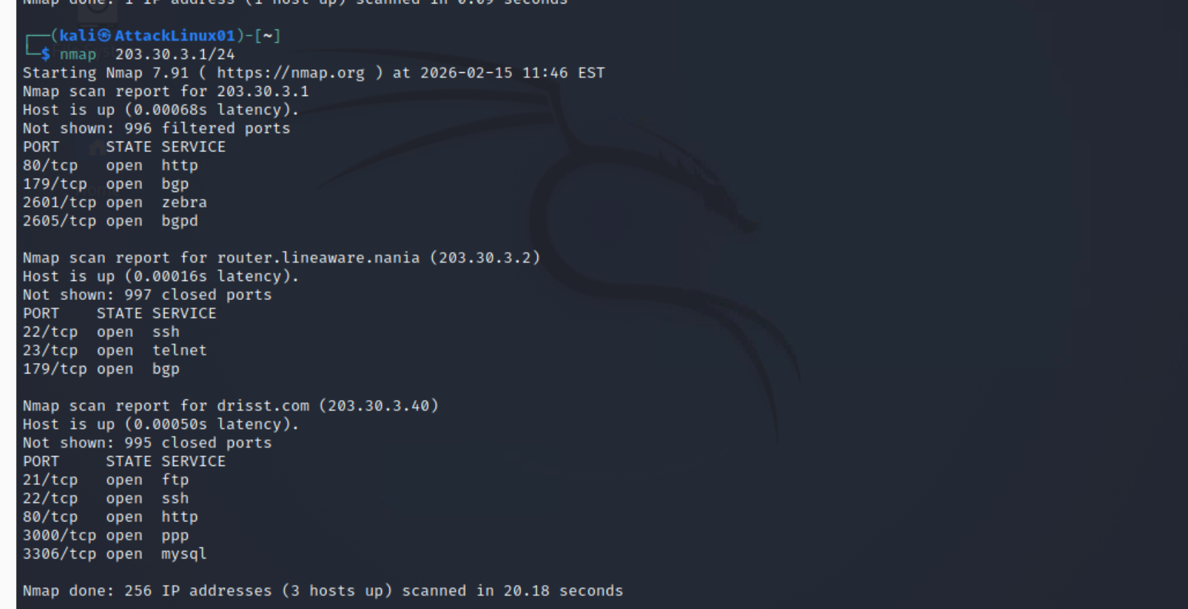
9.
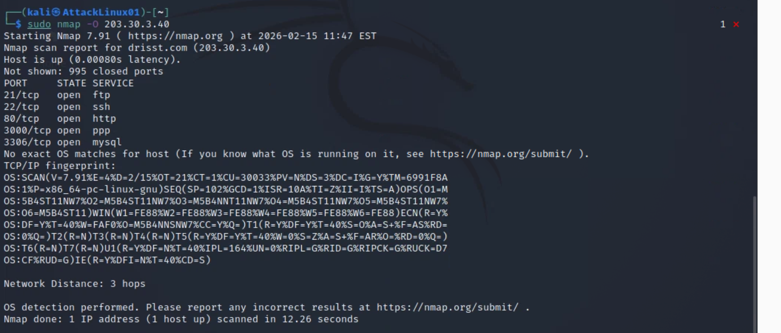

section 2 part 1 is completed here-

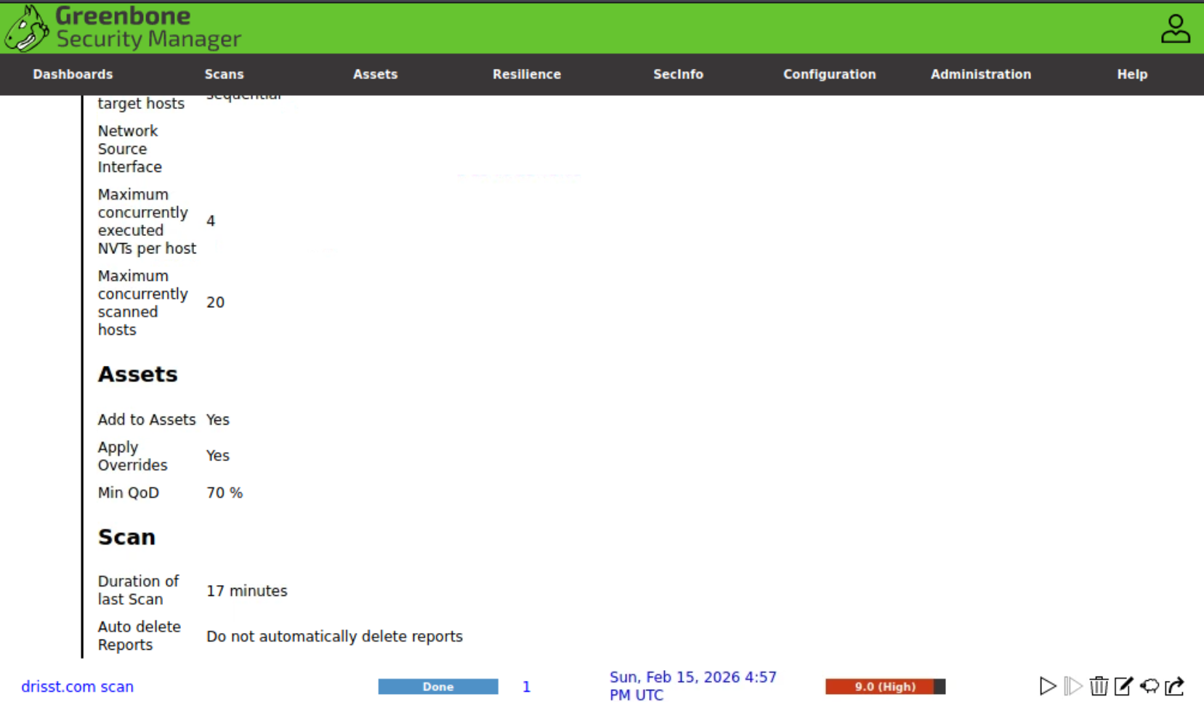
Scanning completed for drisst. Co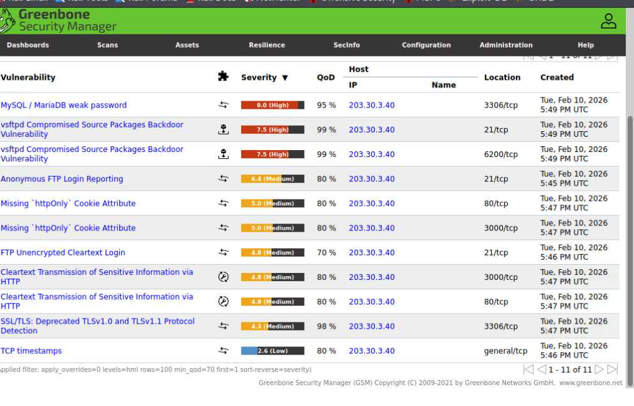
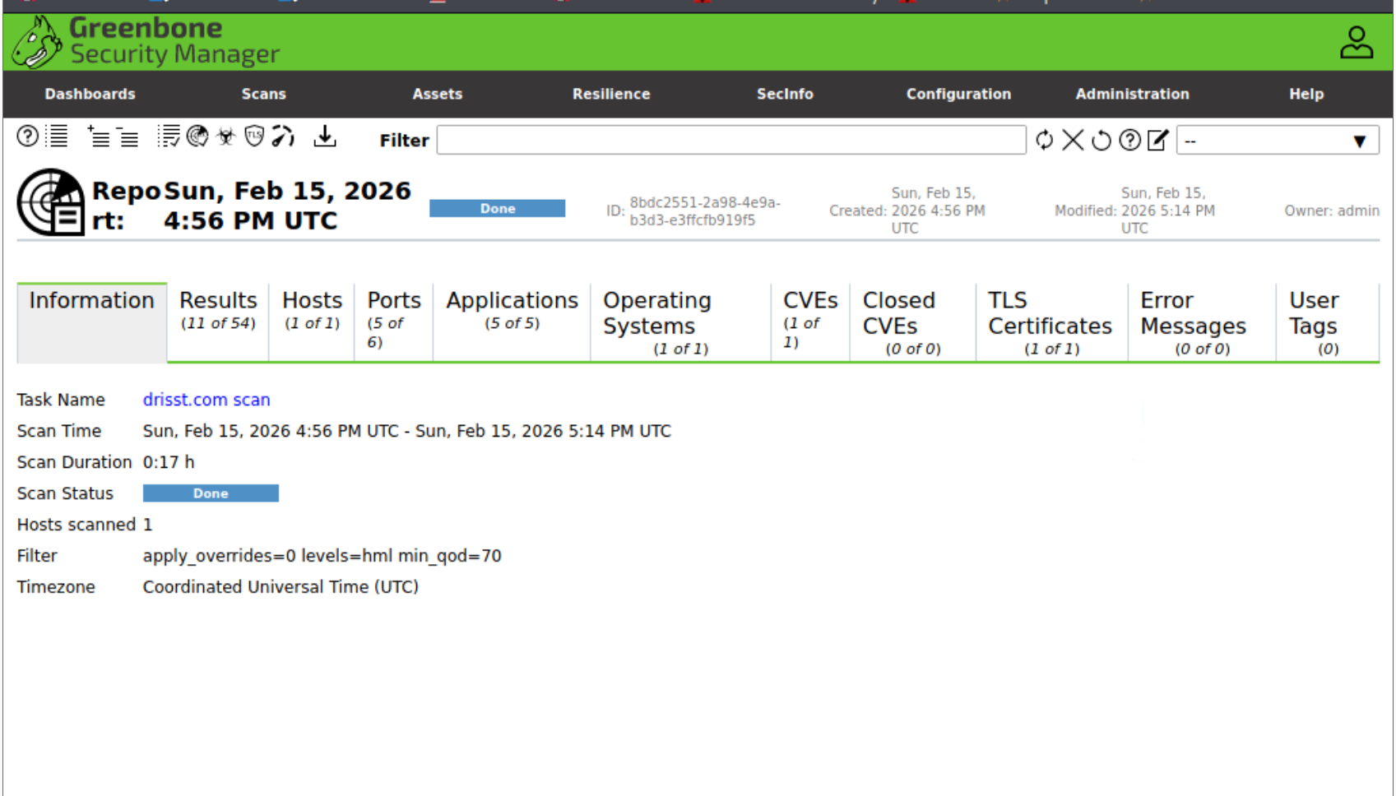
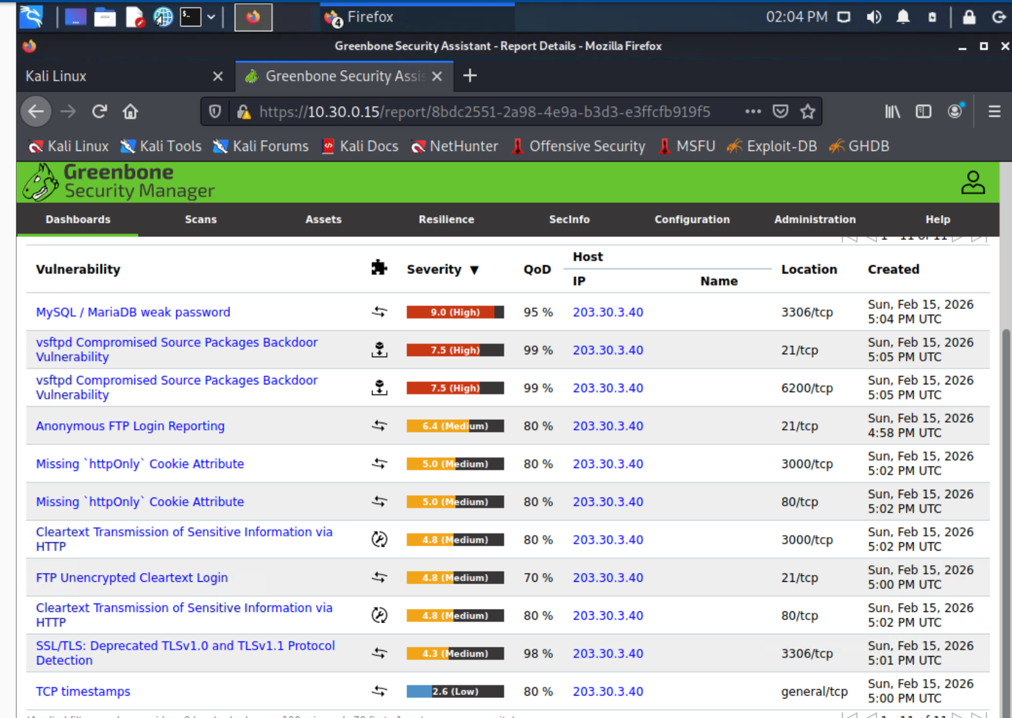the above screen shot shows the result of drisst.com scan

Part 3 of section 2
Vulnerability 1: MySQL / MariaDB Weak Password
Severity: High (CVSS 9.0)
Description:The OpenVAS scan identified that the MySQL/MariaDB database service allows authentication using weak credentials. This indicates poor password policy enforcement and exposes the database service to brute-force or credential guessing attacks.
Vulnerability 2: vsftpd Compromised Source Packages Backdoor Vulnerability
Severity: High (CVSS 7.5)CVE: CVE-2011-2523
Description:The scan detected a vulnerable version of vsftpd (Very Secure FTP Daemon) that contains a malicious backdoor. This backdoor was introduced in a compromised version of the software and allows remote attackers to execute arbitrary commands.
Vulnerability 3: vsftpd Backdoor Service Running on Port 6200
Severity: High
Description:The backdoor associated with the compromised vsftpd service opens a shell listener on TCP port 6200. This allows unauthorized remote access without authentication.

Section 3 part 1
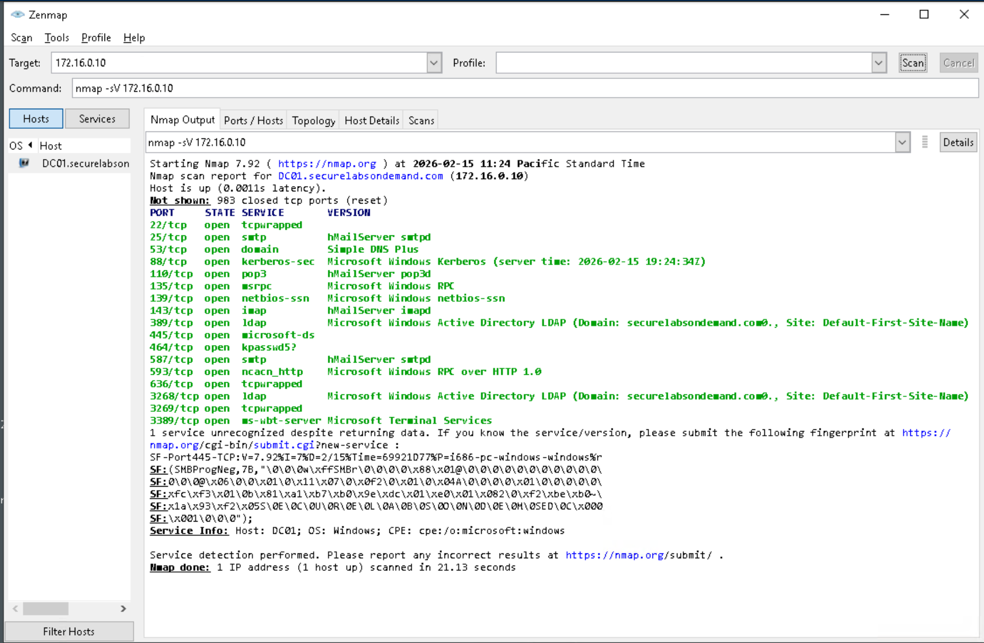

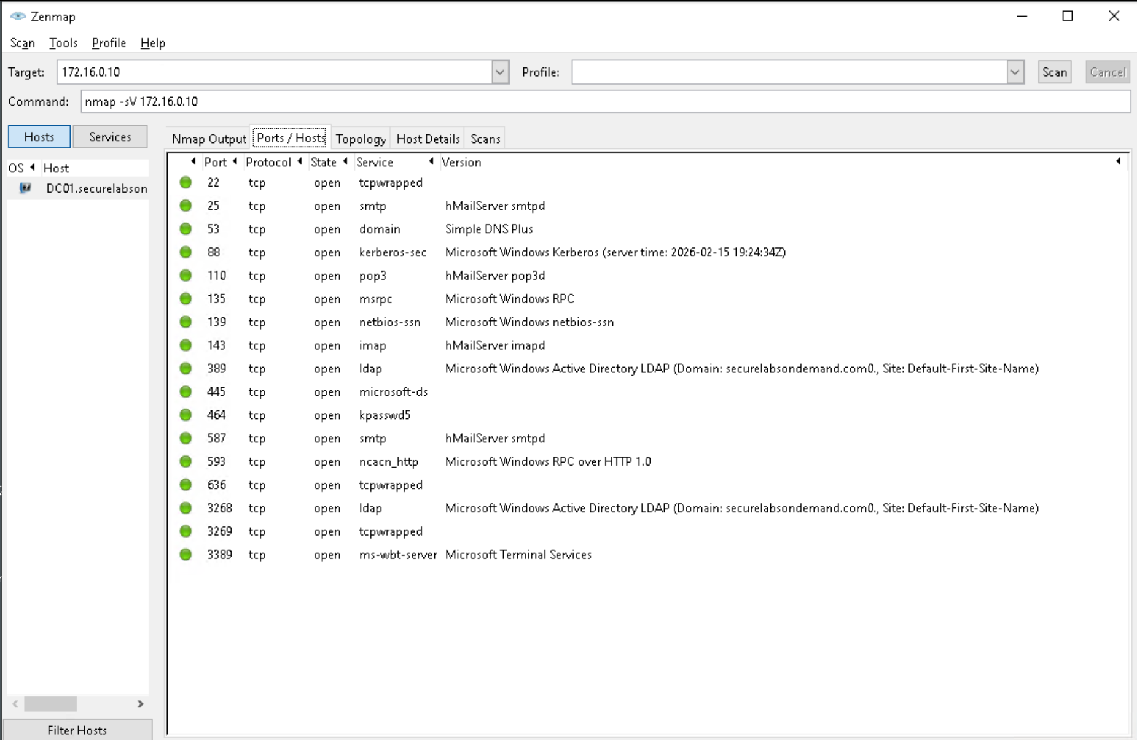
Ports
389 port
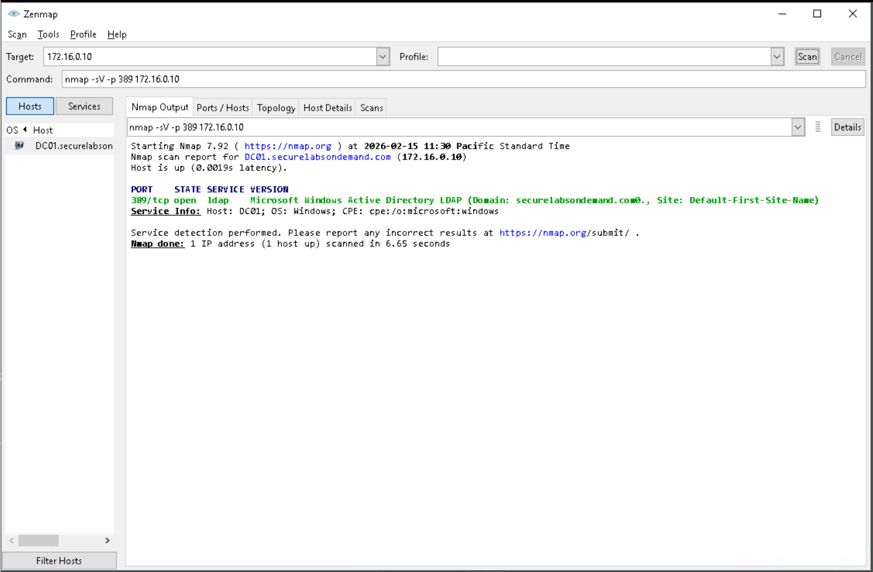
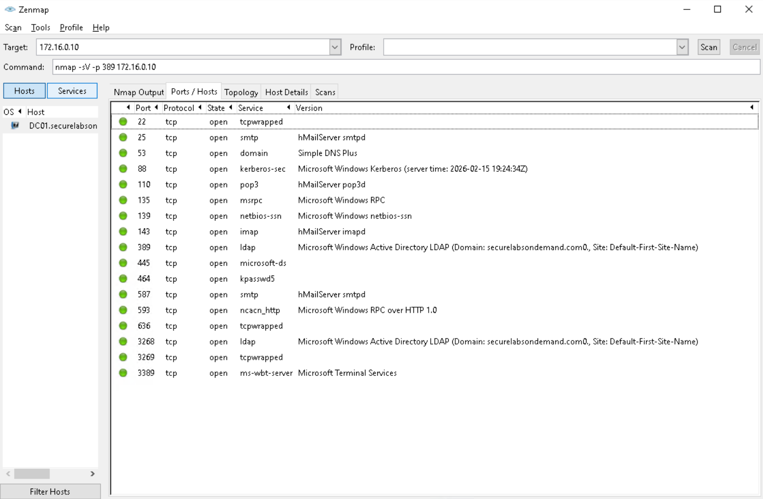

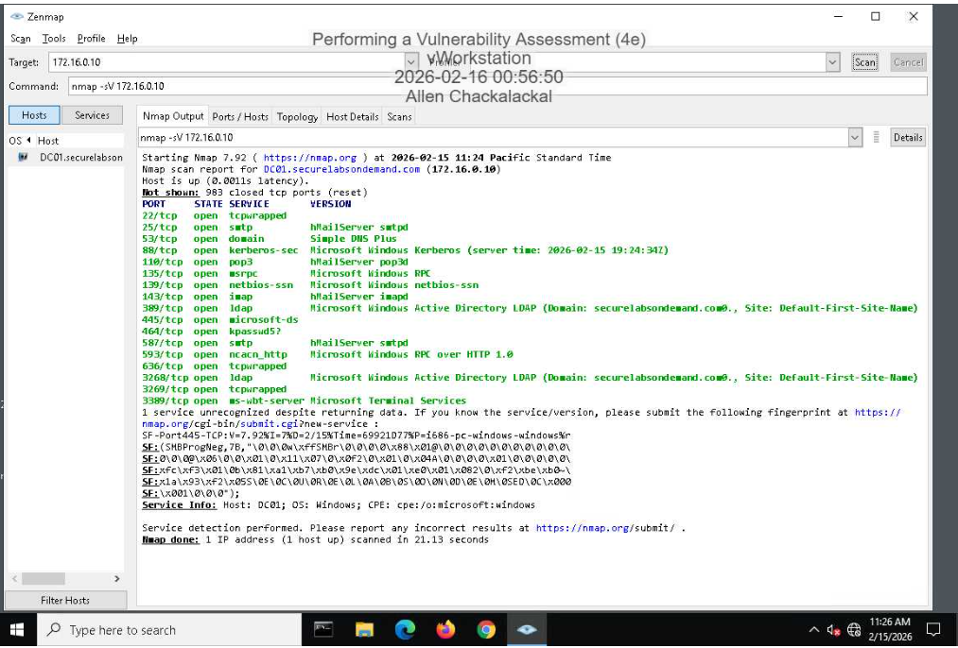

Part 2
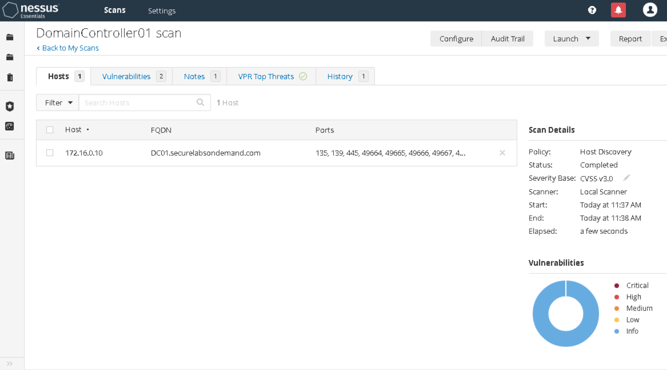
Report of the domaincontroller Nessus scan
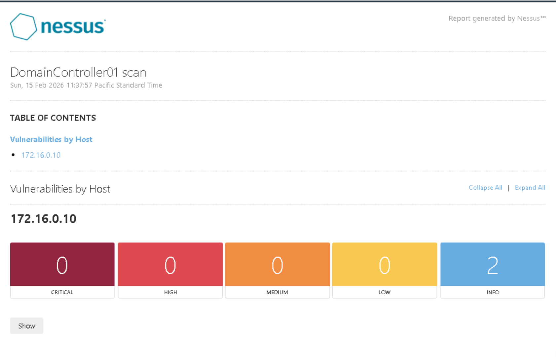
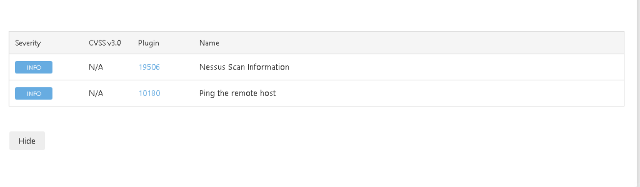

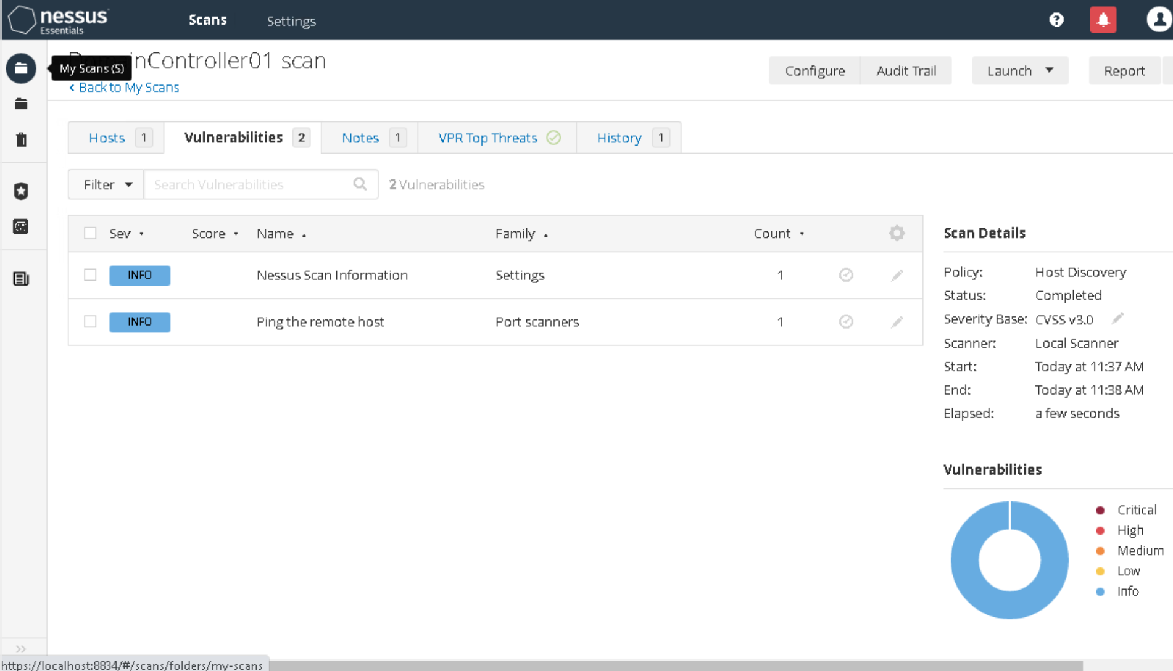
Vulnerability report

